Kevin McMahon
11-29-2025

Module 6 Deliverable
Web Analytics Dashboard Design and Interpretation

CIS4836CCBE Section 01CBE Web Analytics

Evelyn Zayas


To: YouTube Data Analytics Division
From: Kevin McMahon, Web Analytics Specialist
Subject: Web Analytics Dashboard Proposal
Date: 11/29/2025

Introduction
YouTube is one of the largest digital platforms in the world, and the company depends on data to guide decisions related to audience behavior and content performance. A tailored analytics dashboard will help highlight performance indicators that matter most to creators, advertisers, and platform decision makers. The goal for this project is to build a dashboard that presents data clearly so that activity trends can be recognized without effort or confusion. The interface will display user activity, revenue outcomes, content reach, and traffic performance so that anyone reviewing the data can take action based on what they see.

1. Identification of Metrics
The platform produces vast amounts of trackable activity. The dashboard will focus on metrics that reflect content performance and viewer engagement, since those points have the strongest influence on revenue and growth. The most valuable metrics for YouTube include:
- Watch Time
Shows how long viewers remain on content. This metric reflects viewer satisfaction and signals whether videos hold attention.
- Views
Tracks the number of times content is played. A rise in views across videos can indicate stronger reach and higher content discoverability.
- Click Through Rate (CTR)
Measures how often impressions convert into views. This number helps identify which thumbnails and titles attract users effectively.
- Subscriber Change
Reflects long term loyalty and audience attachment. When subscribers increase on videos with high watch time, YouTube can identify which content deserves promotion.
- Revenue Breakdown (Ad Revenue and Membership Revenue)
Helps decision makers evaluate income sources and how they shift over time.
- Traffic Source Performance
Shows how users access content such as search, suggested videos, external pages, or home feed. This helps guide thumbnail strategy, SEO, and placement decisions.

2. Dashboard Structure and Design
The final dashboard will be designed in Microsoft Excel using charts that match the role of each metric for quick interpretation and Tableau or other software for heatmap. This dashboard will be organized so that the most critical engagement metrics appear first, followed by creator growth, then revenue outcomes, and finally traffic source details.
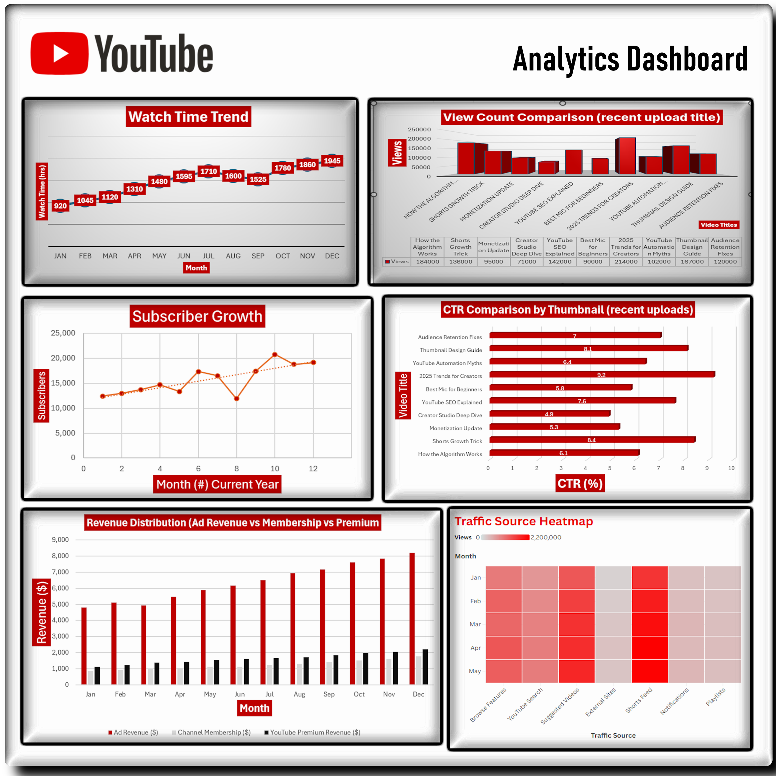

Layout plan:
- Top Section – Watch Time trend line that shows total hours watched per month. View count column chart that compares content performance by video.
- Middle Section – Subscriber growth visualized with a rising or declining line plot. CTR visualized with a bar graph that compares thumbnails and titles.
- Bottom Section – Revenue distribution chart to contrast ad revenue with membership and premium revenue. Traffic source heat map to show how users enter content.

3. Dashboard Interpretation and Analysis

Interpretation
Watch Time reveals how well content holds interest. If the graph shows a climb during specific months, creators can replicate those upload patterns. If it falls, pacing adjustments may be needed. Views reflect reach and discovery strength. A rise in views without matching watch time may signal appealing thumbnails but weak retention once the video begins.
CTR will show how well titles and thumbnails convert browsing users into viewers. A low CTR during months with high impressions means new designs or better keywording may improve performance. Subscriber shifts reflect long term audience value. A spike in subscribers after certain videos shows which content builds real community. Revenue breakdown allows YouTube to see which income source deserves optimization. If ad revenue drops while premium or membership revenue increases, the creator or platform may invest more in exclusive content features.
Traffic source distribution tells decision makers where viewers come from. Strong search traffic rewards keyword placement, while high suggested video traffic rewards high engagement and strong topic relationships. If external embeds increase, partnership outreach may be working well.

Analysis
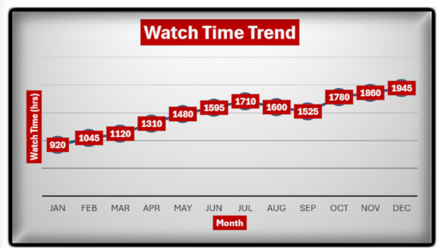
Watch hours rise steadily across the year, starting at 920 hrs in January and ending at 1945 hrs in December. Growth is strongest between March and June, with a small dip in August before momentum builds again through fall. The upward finish suggests stronger viewer engagement over time and a content strategy that improved as the year progressed.
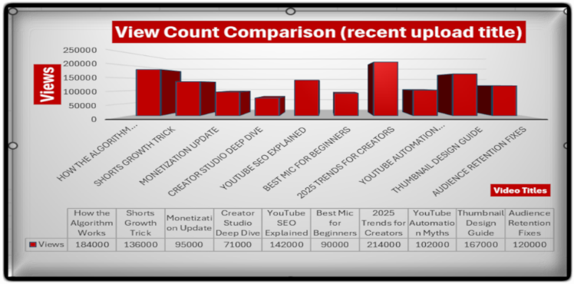
Recent uploads show strong variation in performance. “2025 Trends for Creators” (214k) and “How the Algorithm Works” (184k) lead by a wide margin, suggesting high interest in platform growth and algorithm insights. Mid-range performers like “Thumbnail Design Guide” (167k) and “YouTube SEO Explained” (142k) show steady demand for creator education content, while lower view uploads such as “Creator Studio Deep Dive” (71k) and “Best Mic for Beginners” (90k) may need stronger thumbnail/title pairing or placement timing.
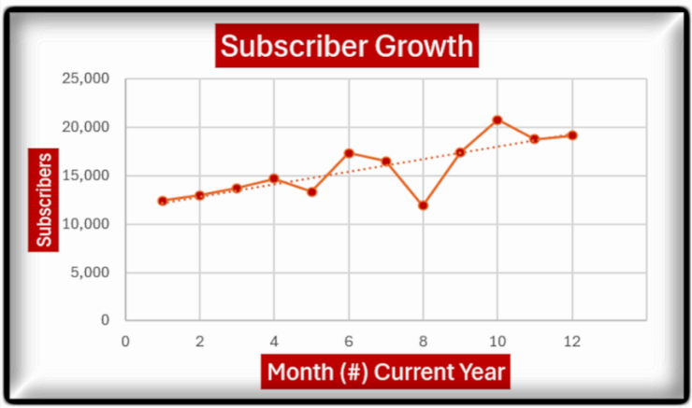
Subscriber count steadily rises through the year with a strong jump around June (6) and another peak near October (10), suggesting effective content or campaigns during those periods. The dip in August (8) may reflect weaker uploads or reduced engagement but recovery is quick. Overall trend points upward, showing a healthy growth momentum.
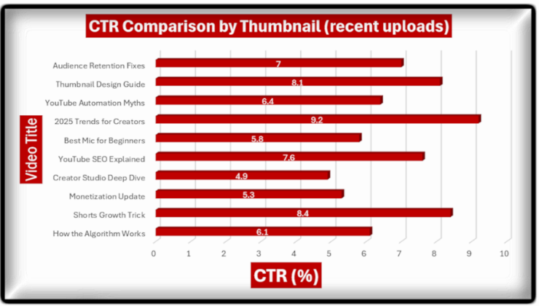
Thumbnails matter on this chart. 2025 “Trends for Creators” leads with the highest CTR, followed by “Shorts Growth Trick” and “Thumbnail Design Guide”. Lower CTR videos like “Creator Studio Deep Dive” may need stronger titles or visuals. Improving thumbnails and headlines could lift click through across creators uploads.
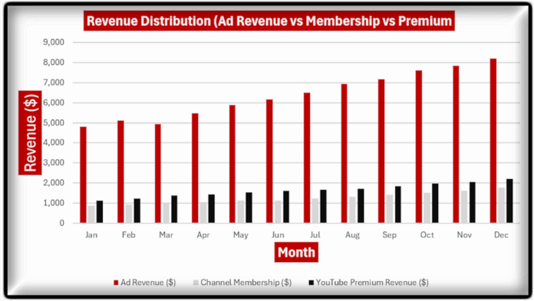
Ad revenue makes up most earnings and rises month to month. Membership and Premium income increase at a slower rate, but still move up steadily. Growth is strongest in the last quarter, suggesting higher viewer activity or better ad placement toward year’s end.
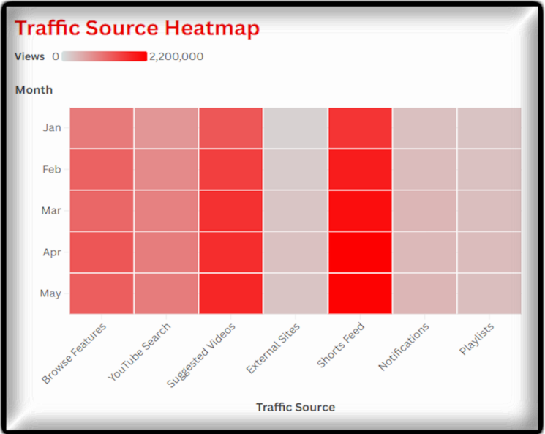
Shorts drive the most traffic across all months, followed by Suggested Videos and Browse Features. External Sites contribute the least, and Notifications and Playlists remain moderate but steady. The pattern suggests Shorts are the strongest growth lever, while external referral efforts may need reinforcement.

Conclusion
Each metric supports YouTube in shaping platform growth and content direction. High watch time pushes the algorithm to recommend content more frequently which leads to greater visibility. CTR guides thumbnail and title design choices so creators can pull in new viewers more easily. Subscriber increases reflect community satisfaction and help forecast future engagement. Revenue breakdown supports budgeting decisions and can change where the company invests. Traffic source data gives feedback on search ranking strength and content recommendation quality.
When these metrics are reviewed together, decision makers get a better picture of what works. They can accelerate successful content strategies while adjusting weak areas before they harm reach. Clear visuals reduce guesswork and support confident decisions that drive growth.

References
Google. (2025). YouTube Analytics and reporting metrics overview. YouTube Help Center.
https://support.google.com/youtube/answer/9002587
Statista. (2025). YouTube usage and engagement statistics worldwide.
https://www.statista.com/topics/2019/youtube
Hootsuite. (Feb 6, 2025). YouTube analytics explained: How to measure performance and grow a channel.
https://blog.hootsuite.com/youtube-analytics
Google Data Analytics Team. (2025). Understanding watch time, ctr, and audience retention in youtube channels. Google Developer Resources.
https://developers.google.com/youtube/analytics

